Blast Search result
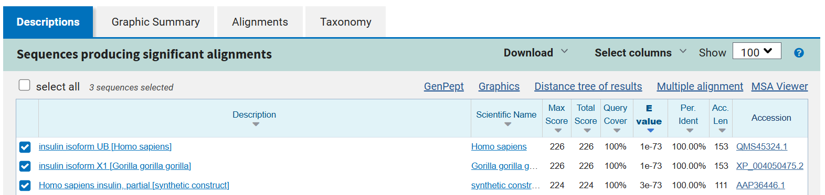
Summary
- I searched a Homo sapiens Insulin protein sequence using NCBI and copied the sequence, then searched a Protein BLAST (blastp) and paste it in the Query box against the non-redundant protein database (nr).
- The top hit was insulin isoform UB from Homo sapiens, accession QMS45324.1, with 100% identity and an E-value of 1e-73.
- The second hit was insulin isoform X1 from Gorilla gorilla gorilla, accession XP_004050475.2, with 100% identity and an E-value of 1e-73.
- The third hit was partial human insulin from a synthetic construct, accession AAP36446.1, with 100% identity and an E-value of 3e-73.
- The E-value indicates the likelihood of obtaining a match by chance; a lower E-value represents a more statistically significant match.

